**“Ethereum Based Decentralized Exchange”**

**Major Project Report**

**As a Partial Requirement for the degree of**

**Master of Computer Application (MCA)**

**Prepared and Submitted By:**

16MCA028 Anar Modi

**Guide By:**

Prof. Rasendu Mishra



**Department of Computer Science & Engineering Institute of Technology**

**Nirma University Ahmedabad 382 481**

**May 2019**

**CERTIFICATE**

This is to certify that the Major Project Report entitled "Etherum Based Decentralized Exchange" by Anar Modi towards the partial fulfillment of the requirements for the award of degree in Master of Computer Applications of Nirma University is the record of work carried out by him under our supervision and guidance.

The work submitted has in our opinion reached a level required for being accepted for examination. The results embodied in this major project work to the best of our knowledge have not been submitted to any other University or Institution for award of any degree or diploma.

Date : 08-05-2019

**Prof. Rasendu Mishra** Delivery Manager

Assistant Professor **Varshal Patel**

Computer Science & Engineering OpenXcell Technolabs

Institute of Technology, Ahmedabad.

Nirma University,

Ahmedabad

**Dr. Anup Singh**  **Dr. Sanjay Garg**

Director General Head, Computer Science &

Nirma University Computer Engineering Department,

Ahmedabad. Institute of Technology,

Nirma University,

Ahmedabad

DATE:

TO WHOMSOEVER IT MAY CONCERN

This is to certify that Anar Hemant Modi (Roll NO: 16MCA028),student of Institute of Technology,

Nirma University Ahmedabad has worked in OpenXcell Technolabs Pvt. As a Project Trainee

from January 01,2019 to May 08,2019

She has completed the project ‘”Etherum based Decetralized Exchange” in the Blockchain Department under the mentorship

Mr.Varshal Patel,Delivery Manager.

She has performed his duties with utrmost dedicated and with high level of engineering and analytical Competence.

We wish him all the best for her Future Endeavours.

Date:08-05-2019

Name of the External Guide

Varshal Patel ,Delivery Manager

Name of the Faculty Guide

Prof. Rasendu Mishra

CONTENT

Acknowlegement

1. INTRODUCTION.

1.1 ABOUT THE COMPANY.

1.1.1 Introduction of the company.

1.1.2 Quality policy.

1.1.3 Communication.

1.1.4 Resources.

1.2 THE SYSTEM.

1.2.1 Definition of system.

1.2.2 Purpose and objectives.

1.2.3 About present system.

1.2.4 Proposed system.

1.3 PROJECT PROFILE.

1.3.1 Project title.

1.3.2 Scope of project.

1.3.3 Project team.

1.3.4 Hardware/Software environment in company.

2. SYSTEM ANALYSIS.

2.1 FEASIBILITY STUDY.

2.1.1 Operational feasibility.

2.1.2 Technical feasibility.

2.1.3 Financial and Economical feasibility.

2.1.4 Handling Infeasible Projects.

2.2 REQUIRMENT ANALYSIS.

2.2.1 Facts-Finding Techniques.

2.2.1.1 Interview.

2.2.1.2 Questionnaire.

2.2.1.3 Record Review.

2.2.1.4 Observation.

2.3 CONTEXT DIAGRAM.

2.4 Analysis Diagram

(Based on Procedural Approach or Object Oriented Approach)

3. SYSTEM DESIGN.

3.1 System flow (Based on Procedural Approach or Object Oriented Approach)

4. User Manuals

4.1 Menu Screens along with Description

5. TESTING.

6. FUTURE ENHANCEMENT.

7. APPENDIX

8.Tools used.

9. BIBLIOGRAPHY.

**ACKNOWLEDGEMENT**

When we reach the completion of the project, giving credit becomes a must, as without the support of others help and guidance, this project couldn’t be completed successfully.

First we would like to thank our parents with their great support we can reach at the stage. Then our humble thanks to all professors and all staff members of our university “Institute of Technology,Nirma Univeristy”.For the co-operation & keep interest extended by them, throughout our degree course. It is the base that they have built, which sustains such good jobs.

We would like to thank Dr.Alka Mahajan the director of the Institute of Technology and Prof Rasendu Mishra for granting us an opportunity to work on this project. We would also like to thank our Internal guide Prof. Rasendu Mishra and our External guide Mr. Varshal Patel for their valued guidance and encouragement towards the completion of our project.

Thanking All.

Anar Modi

# Introduction

# **About the Company**

OpenXcell is CMMI Level 3 software development company established in 2008. Currently, we are the team of more than 200 software engineers, technology consultants and creative designers. Along with software development, we are the pioneers in mobile app development, real-time systems, bot development and IOTs.

We are focused on delivering high-performance and scalable software products to different industries. We have experience of developing and maintaining successful software products, eCommerce portals, marketplaces, social networks, real-time business analytics and composite sync and integrations.

Along with delivering the successful software product, we have experience of building our SaaS-based products:

1. [Orderhive](http://www.orderhive.com/) – Multichannel inventory management system
2. [Workhive](http://www.workhiveapp.com/) – A chat app for the team

Developing, supporting and marketing our product, provided us with a lot of exposure and learning of how to make software product successful.

OpenXcell has won ” Best software development firm ” award from GESIA in 2014 and 2015.

Quality Policy:

The company has pretty sound policy which looks after its employee’s upbringing

by providing them with star Employee of the Year. It has scrum environment

flow and flexible policy and at last its development people follows code review policy

 which sees that all development modules follows coding standards like etc. along with code versioning.

Communication:

Our Product owner Varshal Patel managing our project "Virtual football" along

with our project tech-lead Vinit Mody. We follow agile scrum which includes many scrum

meetings to manage the whole project and in agile we have scrum ritual which is daily

15min stand up meeting where we state what we did yesterday, what we are going to do

today and what are the impediments that we are facing while developing our task and other

than meetings we use slack tool for internal communication.

Resources

The members in Ahmedabad branch mainly consist of development team and business people,management team,testing team ranging in total within 330+ employees.

Infrastructure wise it has one entire floors in Baleshwar venue building

**Definition Of System**

The project can be used by any end user who are willing to invest in the crypto currency by giving the ether in exchange of our token. The token value are decided and kept appropriately.

Crypto currency exchanges that allow customers to transfer ether and Tokens

It even includes the market that takes the bid and approve the appropriate transfer of ethers.

**Purpose and Objective**

A custom block chain would be developed for our tokens which would be a developed on ethereum wallet. It would be based on the public block chain.

Difficulty level of coins will be controlled by mathematical formula, once coin is launched.

In Exchange users can sell and buy the tokens by setting their appropriate price which works same as stock market in real world. It can support more than one tokens or crypto currency.

Project Title:

“Etherum based decentralized Exchange”

**Scope:**

It an website based on Crypto currency exchange (Bitcoin currency) using ethers to transfer using meta mask an extension of Google Chrome.

It stores information related to Bit Coin.

It contains features like safe and secure to transfer ethers and token.

It allows to deposit, transfer and to withdraw tokens and also allows to deposit, transfer and to withdraw ethers which is being approved by allowance.

It Allows to buy and sell token on the basics of the trading and which holds the sell Order and the order Book according to the market prices and the implementation of the limit orders.

### Project team

16MCA028: - Anar Hemant Modi.

## Hardware/Software environment in company

* **Hardware Requirements:**

### Processor: Intel Pentium Family and above

RAM: 2 GB

Hard Disk: 320 GB

* **Software Requirements:**

Front End: HTML,CSS,JAVASCRIPT

Back End: Node.js

# SYSTEM ANALYSIS

## **Feasibility Study**

* It includes possible solutions to a given problem.
* The solution should be as per the requirements of the user.
* It should be flexible.

### Operational Feasibility:

* + The system is user friendly
  + All inputs taken are so easy that it can be understood by the layman.

### Technical and Economic Feasibility

* + It includes the functional and performance of the system.
  + The organization will bear hardware and software cost.
  + The benefits will be more than the total cost the organization will bear.

## REQUIREMENT ANALYSIS

### **Facts-Finding Techniques**

#### Interview

* + We interviewed the client and gathered the information and his requirements about the system.
  + Ex.1 Do you have any existing system with which you want to integrate our system?
  + Ex.2 If yes then, which kind of data you want from that system to perform functions in our system?
  + What are your Approval Requirements ?

#### Questionnaire

* + We gave the client a questionnaire through which he can share his requirements.
  + The client found this way of asking questions effective and easier.
  + Ex.1 Is there any different template for different etherum account?

#### Record Review

* + Whatever the client told us, we recorded so that there is no misunderstanding.
  + There was better clarity of thought.

#### Observation

* + Etherum based decentralized Exchange is used to tranfer Ether.
  + They dont have an proper application to exchange ether and to deposit.

**Diagrams:**

**Class Digarms**



USE CASE DIAGRAMS:



Admin

User

Allowance

Erc 20Tokens

HOME PAGE:

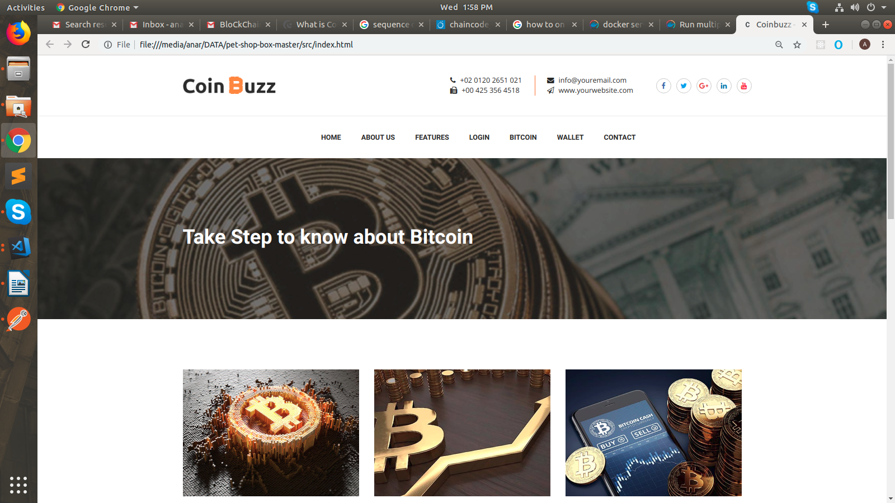

-Home Page the main page of the Entire website which includes the market resourses it even includes the bitcoin prizes.

-Information related to Bitcoin Cryto Currency

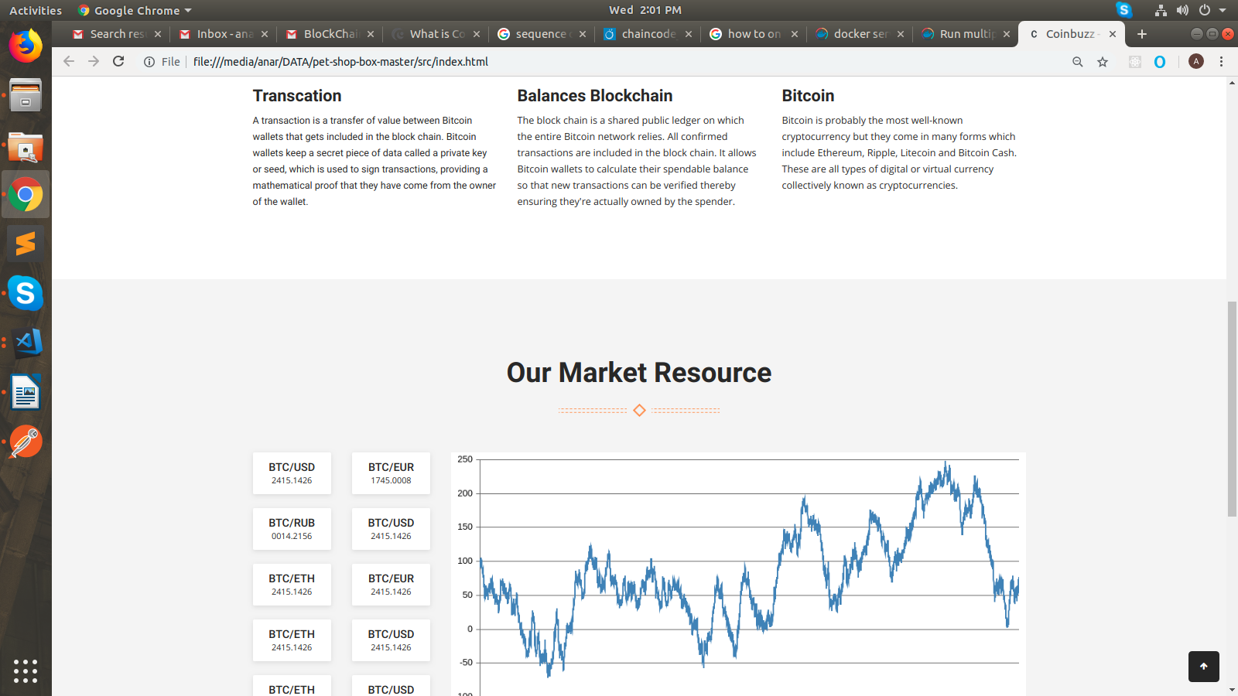

About Us:

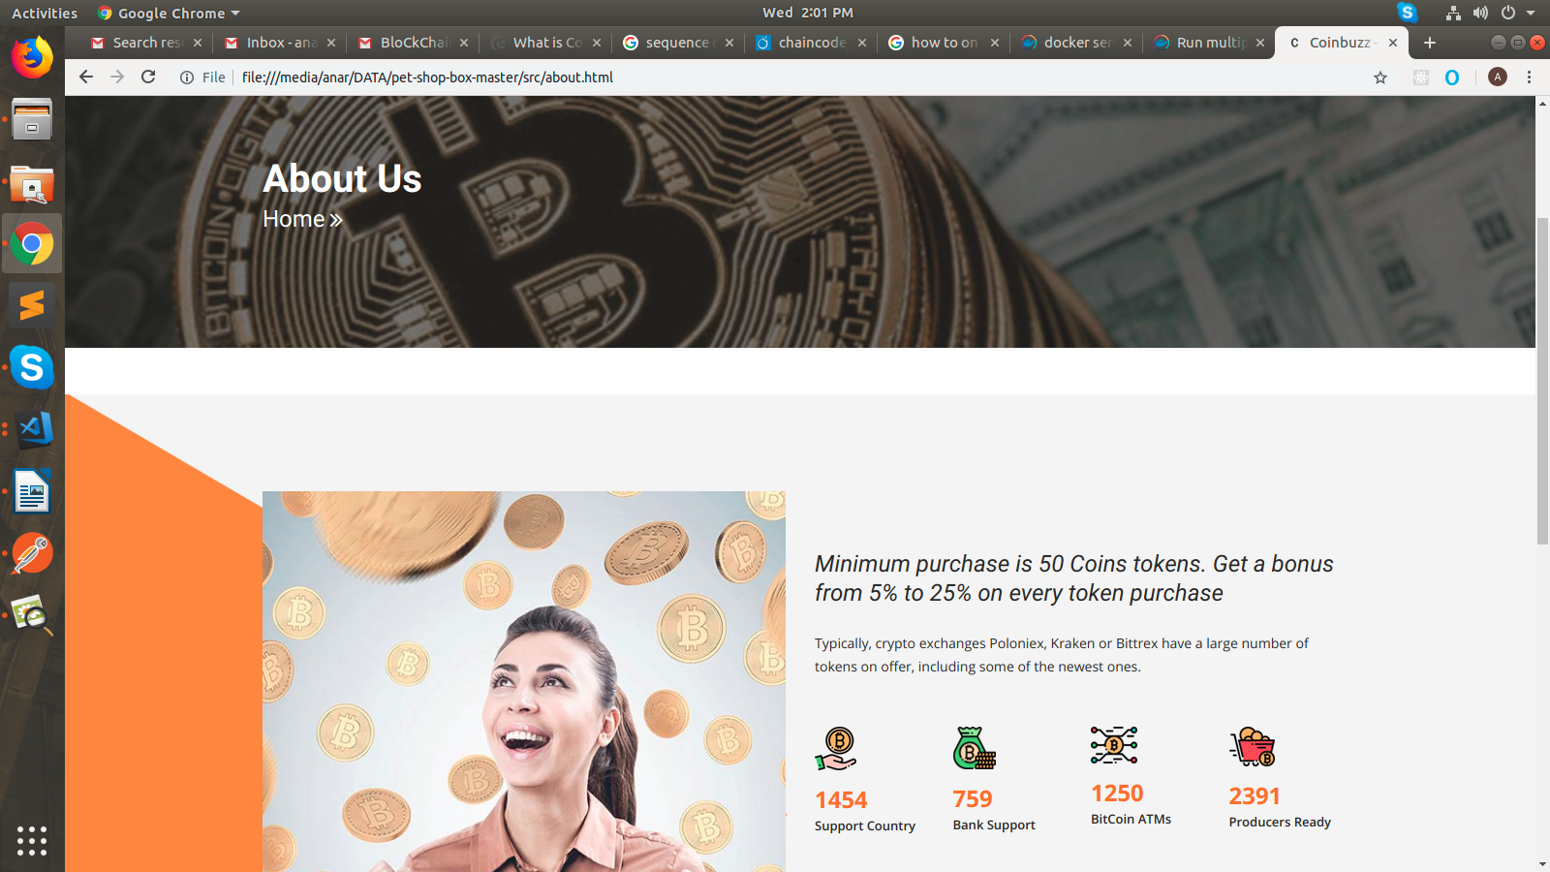

LOGIN PAGE OF ADMIN

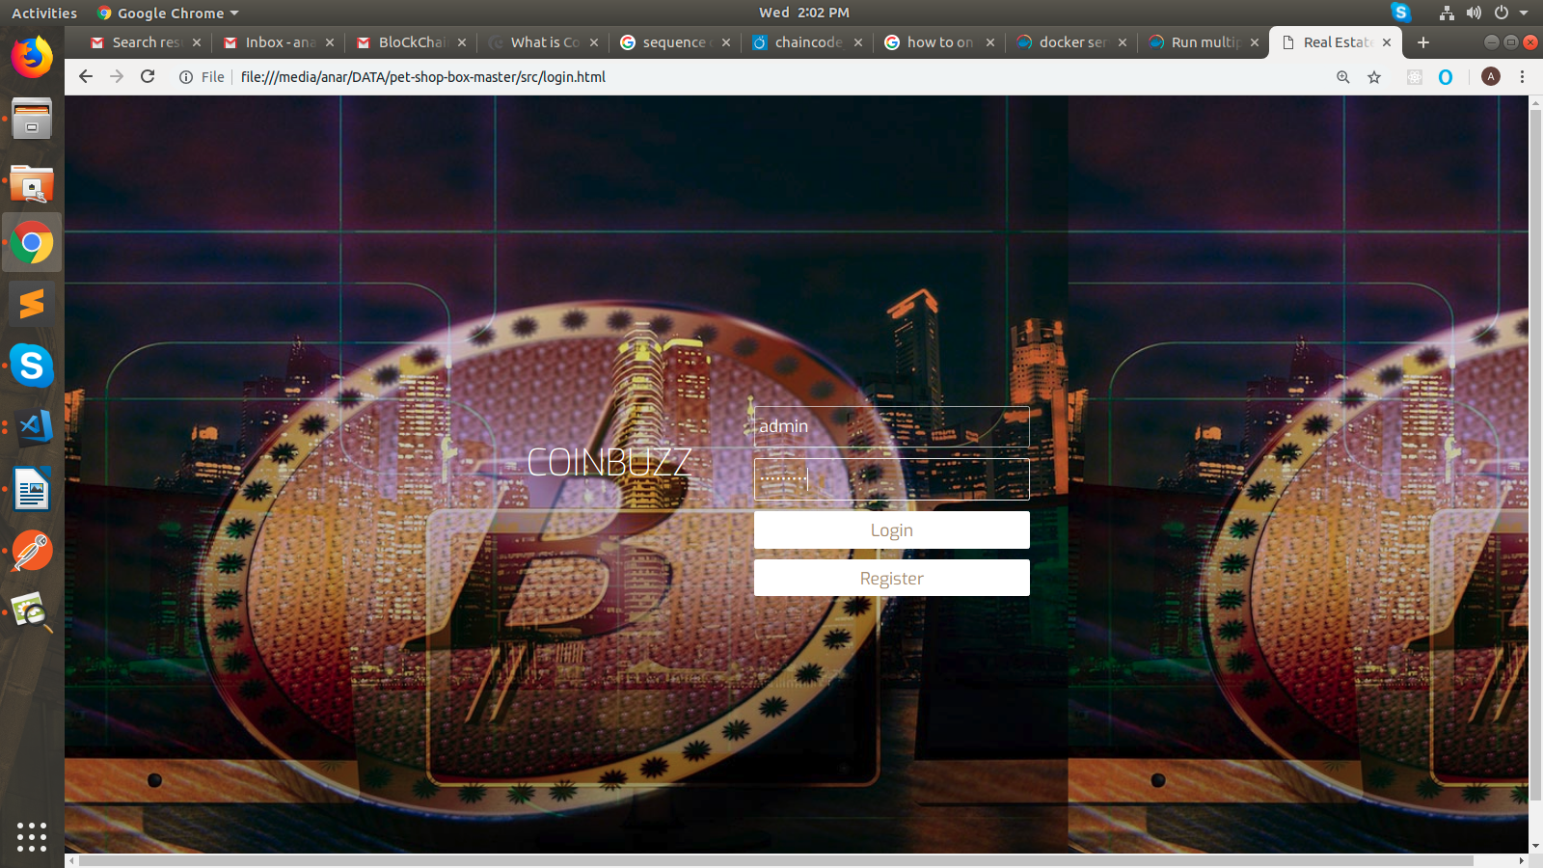

REGISTRATION PAGE OF ADMIN:

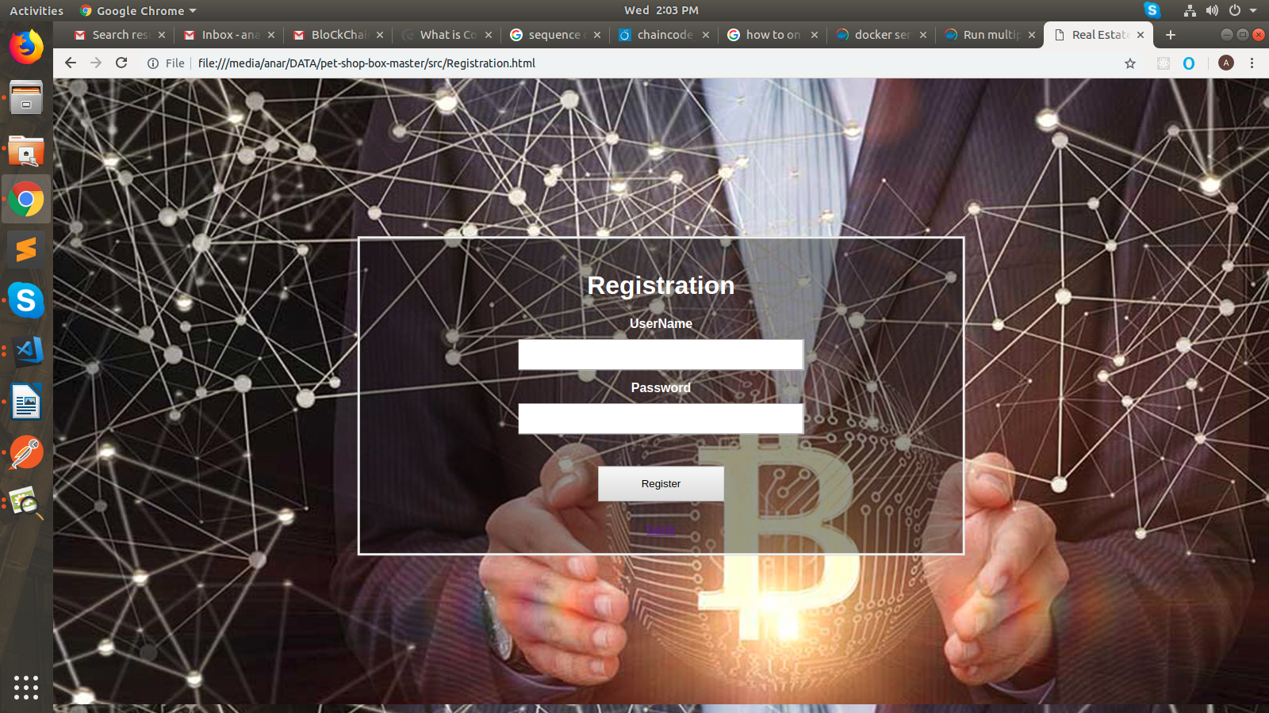

VALIDATION ADMIN SIDE

BITCOIN INFORMATION:

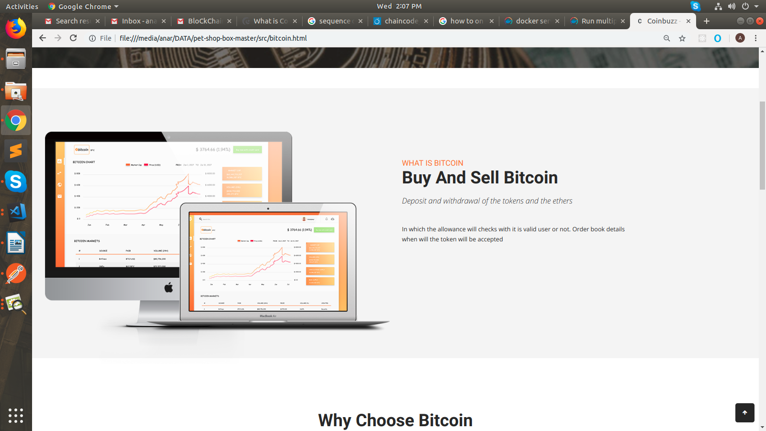

LATEST NEWS OF BITCOIN

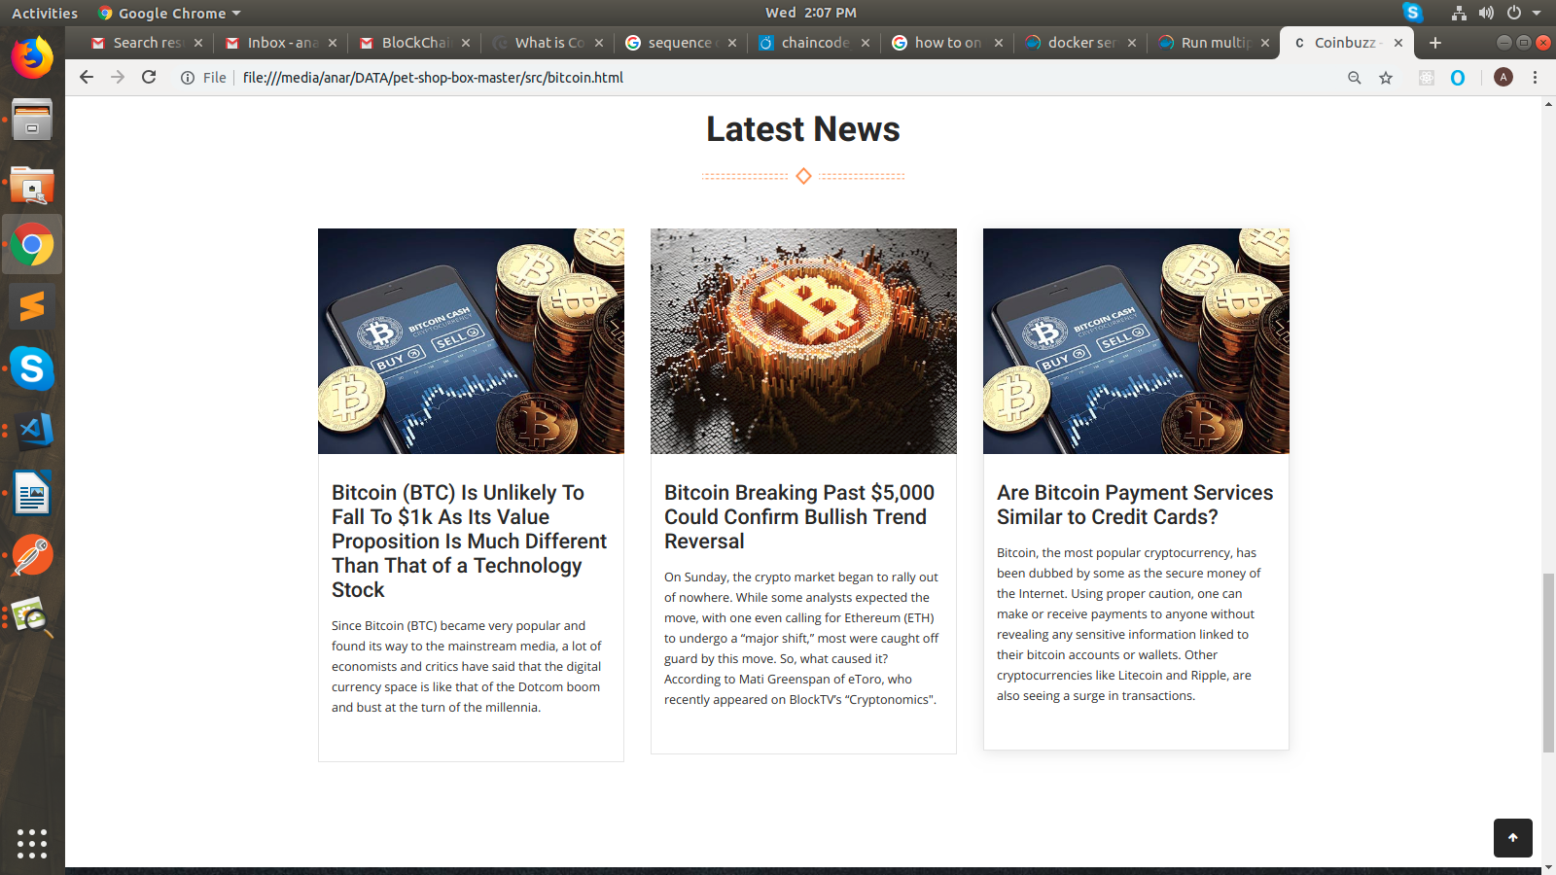

CONTACT US:

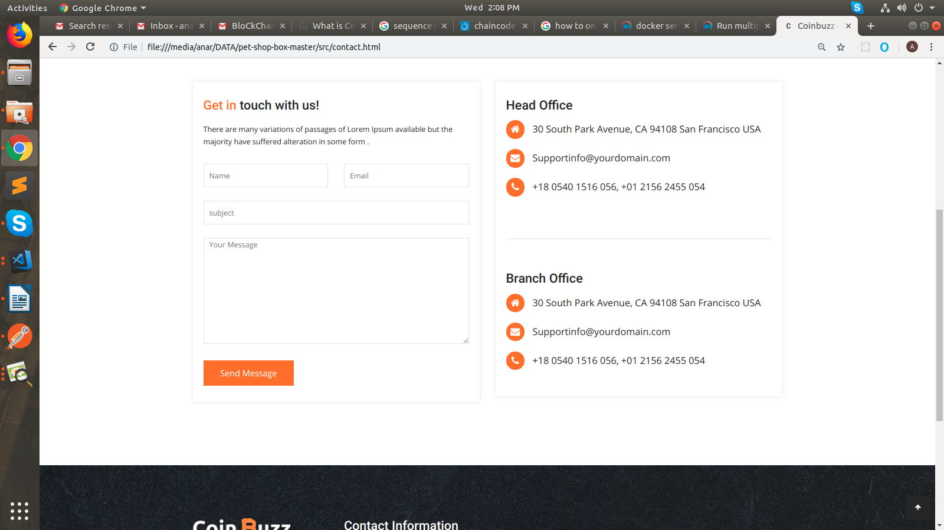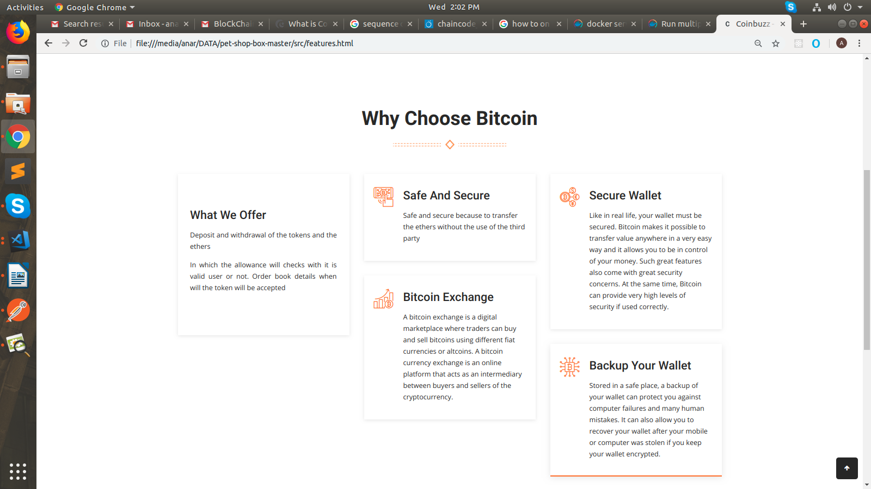

FEATURES:

DEPOSIT TOKEN

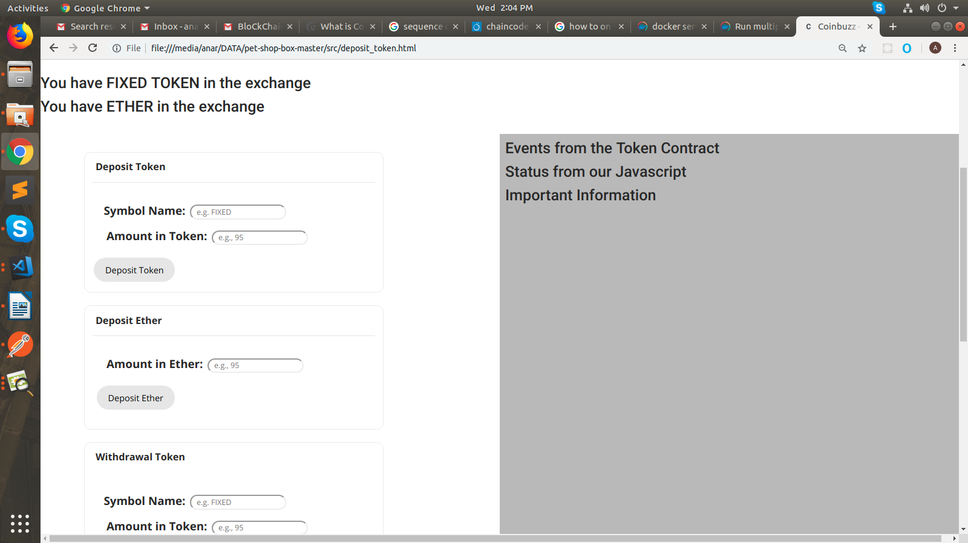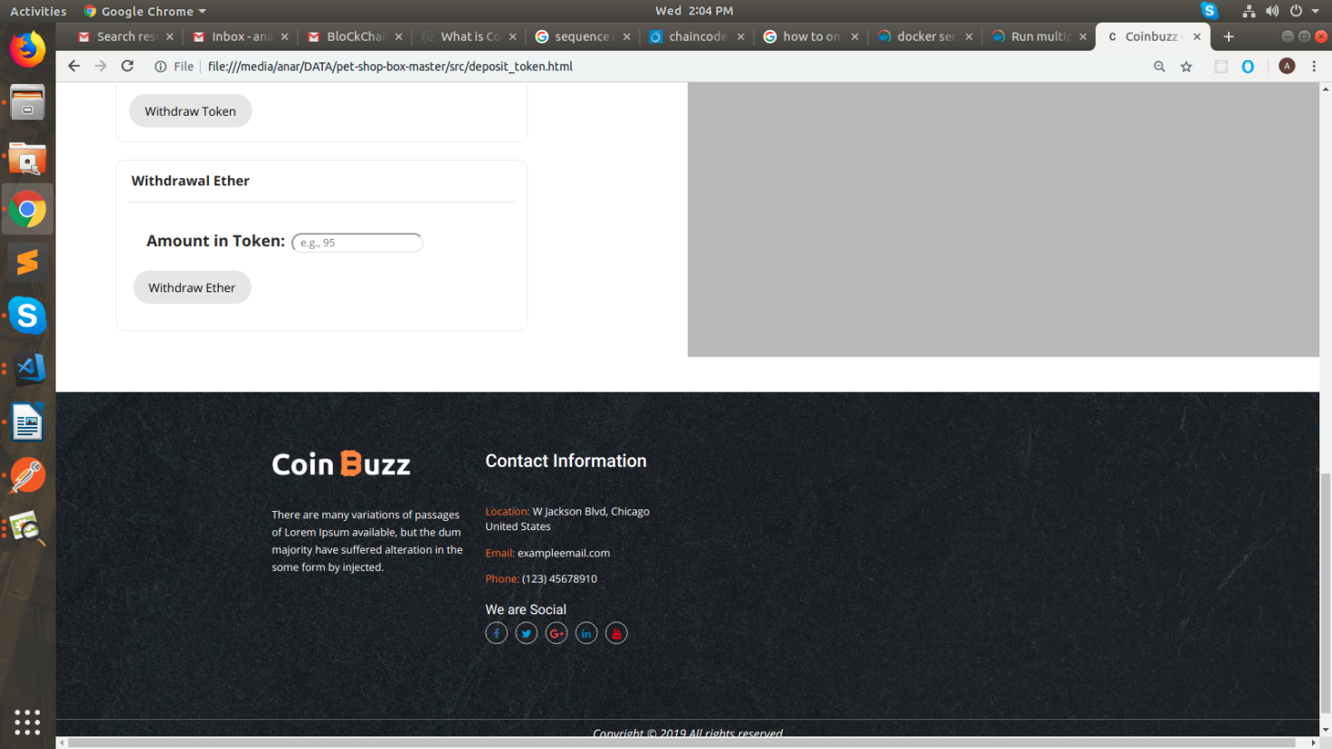

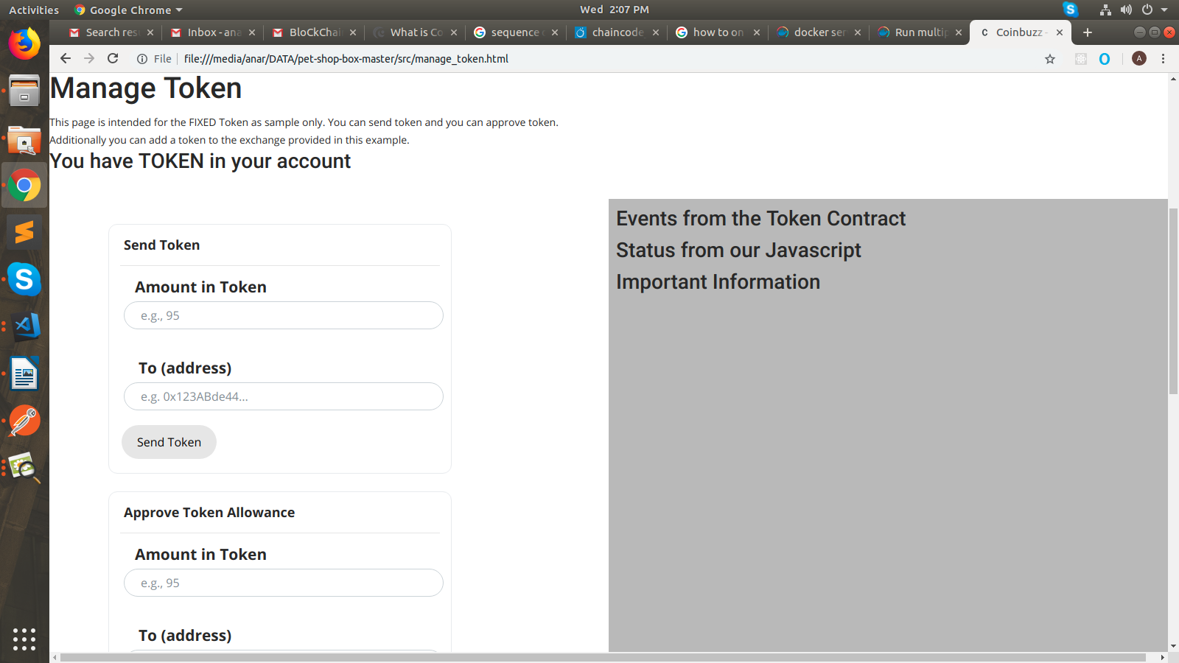 MANAGE TOKEN

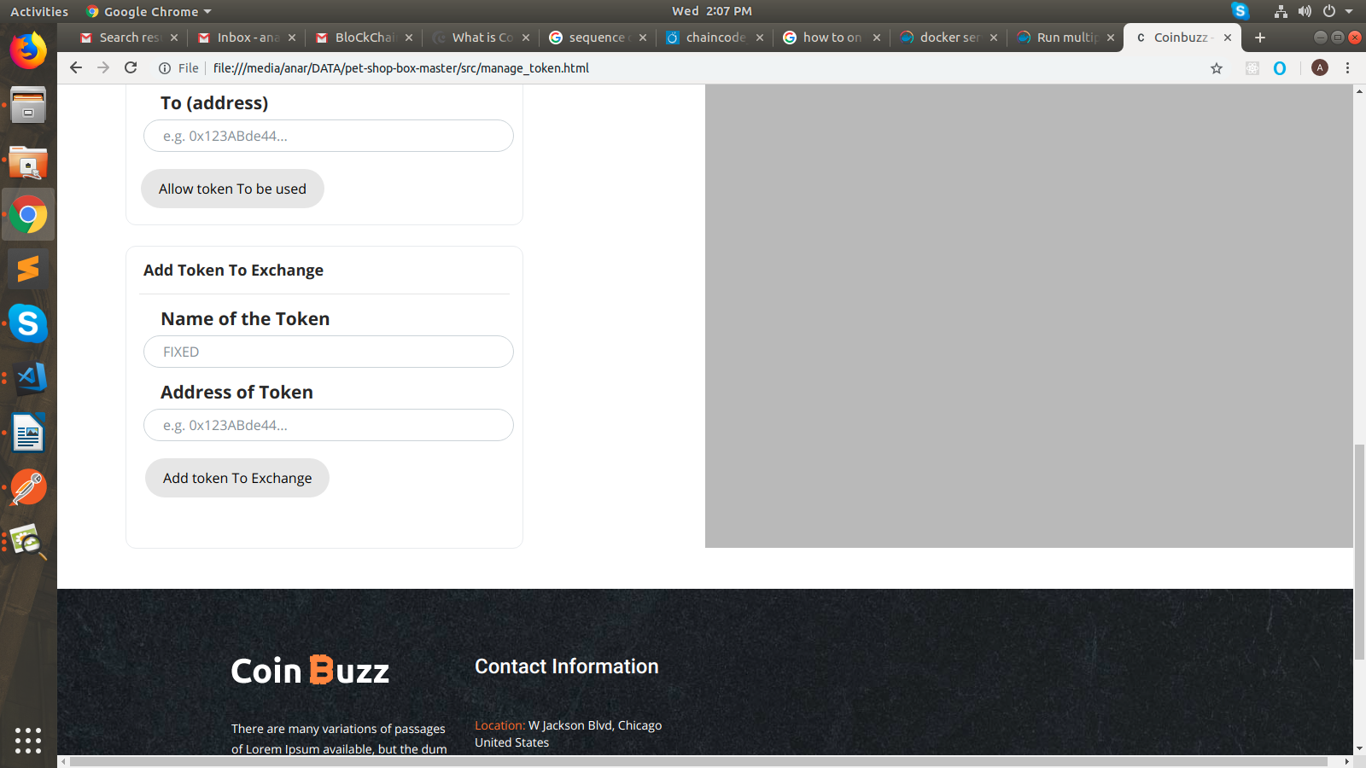

**ADDRESS**

**Work:**

202-203, Baleshwar Avenue, Opposite Rajpath Club, SG Highway, Ahmedabad, Gujarat 380054.

**Home:**

A 704 Satva App PPCC Ground Paldi Ahmedabad.

Mobile –9722232832

**Distance – 8KM**

**Mode of Transportation – Activa**